**Lab 4: Linux Basic Scripting - 2**

1. **Write a menu driven shell script, which will print the following menu and execute the given task.**

* **Display a calendar of current month**
* **Display today’s date and time**
* **Display username those are currently logged in the system**
* **Display your name at the given x,y position.**
* **Display your terminal number.**

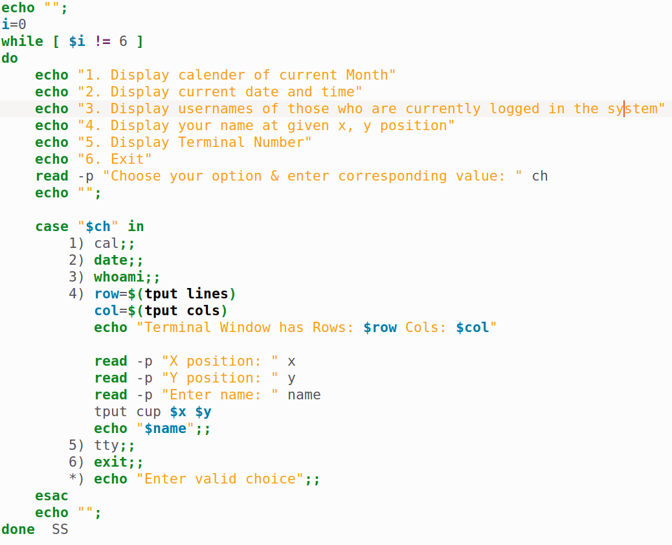

**Output**

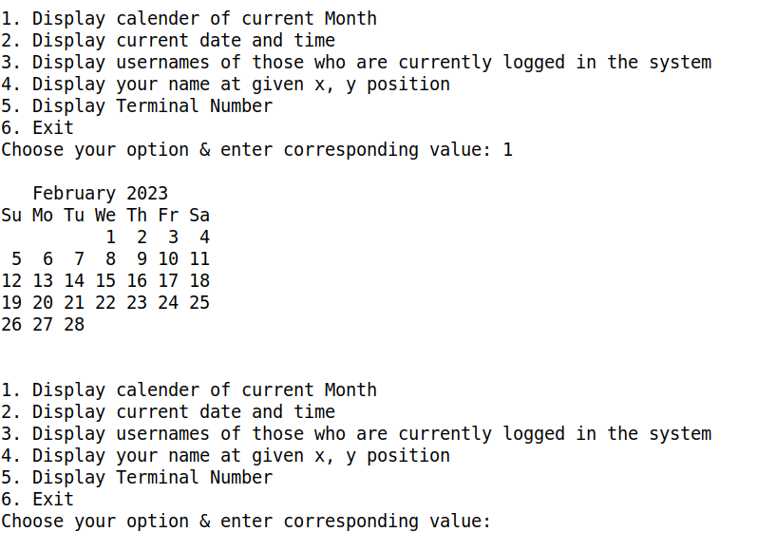

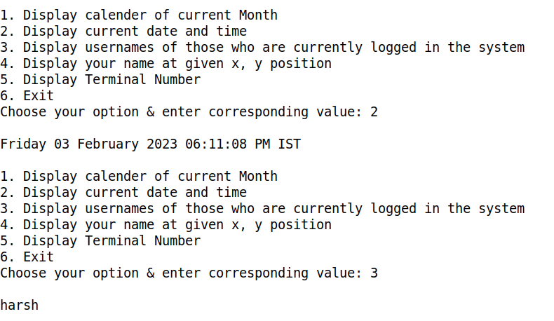

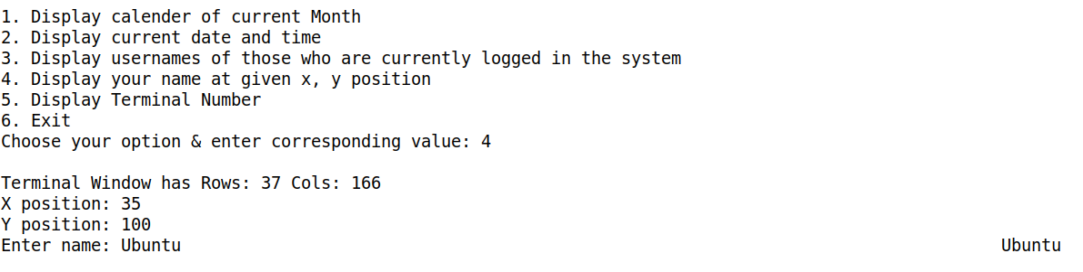

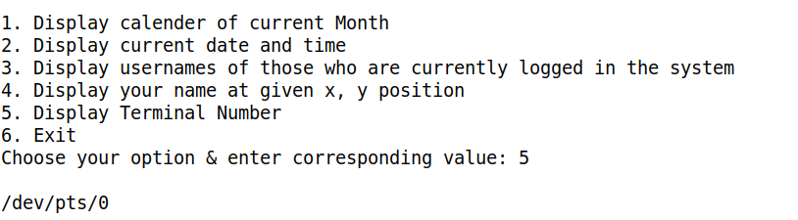

1. **Write a shell script which will generate first n Fibonacci numbers.**

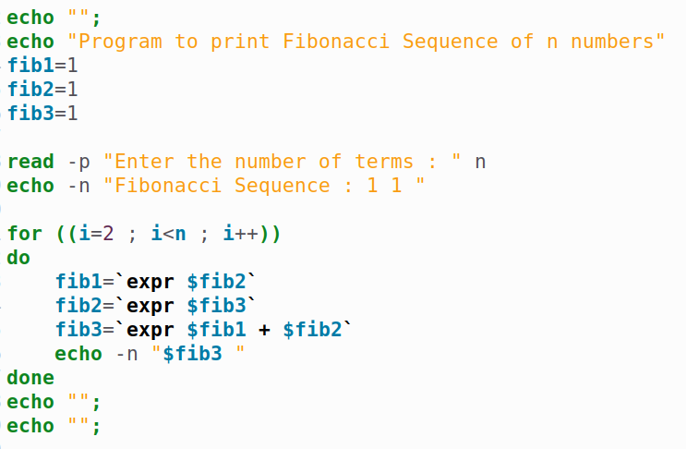

**Output:**

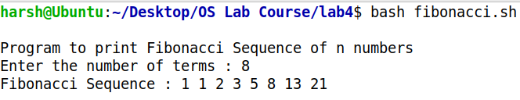

1. **Shell Script to print half pyramids using numbers.**

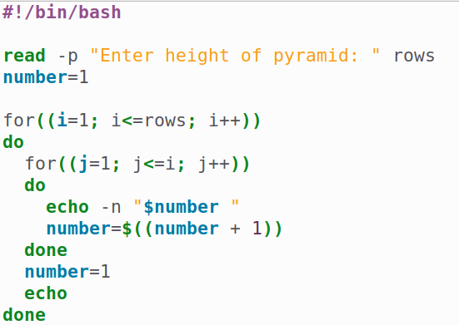

**Output:**

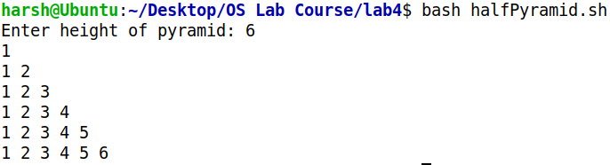

1. **Write a shell script to find the reverse of a given number.**

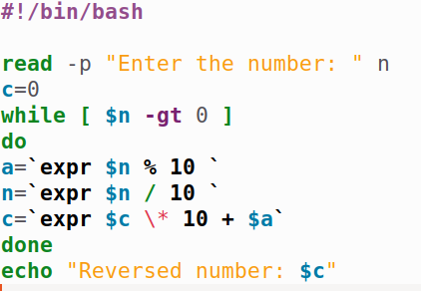

**Output:**

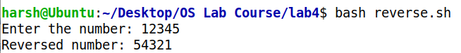

1. **Write a shell script to find the sum of two floating point numbers.**

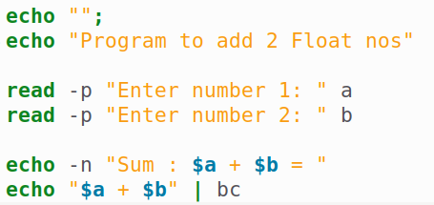

**Output:**

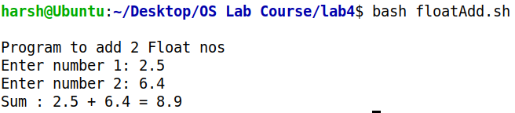**.**

1. **Write a shell script to make the following operations menu based:**

* **Addition**
* **Subtraction**
* **Multiplication**
* **Division**

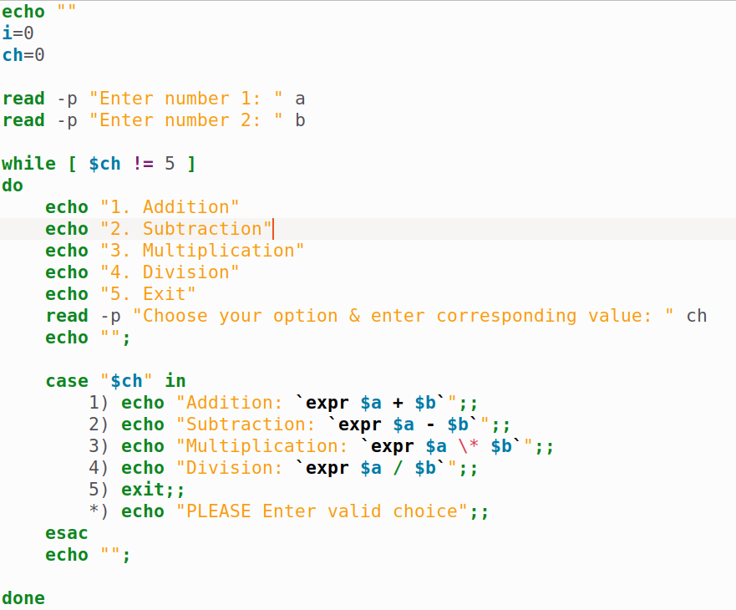

**Output:**

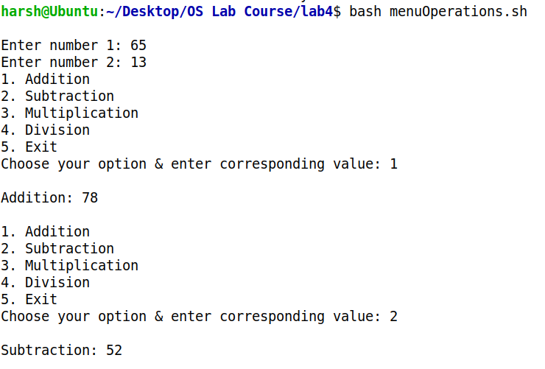

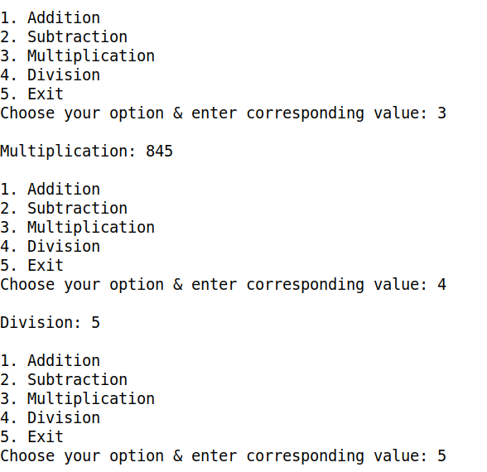

1. **Write a shell script to find the sum of all digits for a given number.**

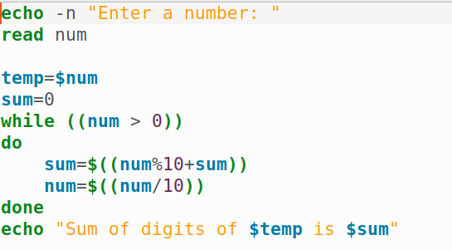

**Output:**



1. **Write a shell script to find the factorial of a given number.**

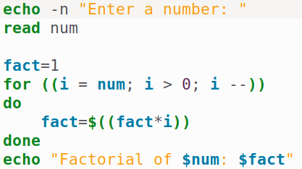

**Output:**

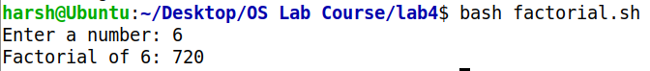

1. **Write a shell script which prints “invalid no. of arguments” if more than 5 command line  
   arguments otherwise print “valid no. of arguments”.**

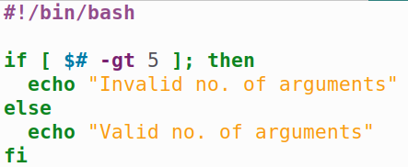

**Output:**



1. **Write a shell script that changes text to uppercase.**

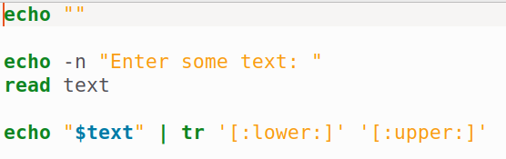

**Output:**

